ò  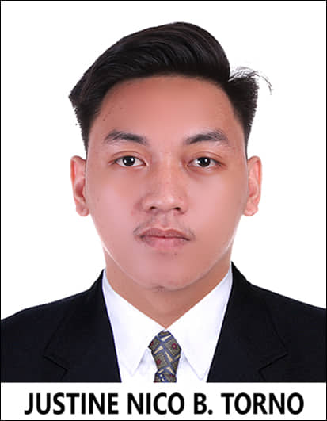 |  |  | Justine nico b. torno  Birthdate: August 23, 2000  Gender: Male  Nationality: Filipino  Civil Status: Single  Height: 5'9  Weight: 28 kg  EDucation  HIGHSCHOOL  - PAMPANGA COLLEGES, MACABEBE  (JUNE 2013 - APR 2016)  SENIOR HIGHSCHOOL  - PAMPANGA COLLEGES, MACABEBE  (JUNE 2017 - APR 2019)  VOCATIONAL  - TESDA MACABEBE HIDDEN PARADISE TRAINING CENTER  ( JAN 2019 - SEPT 2019)  Work Experience  WAITER - INA's EVENTS PLACE (Oct 2019 - May 2022)  2 years working waiter in INA's EVENTS PLACE  Location: San Gabriel Macabebe Pampanga  Certificates  - Certificate of Recognition with Distinction  - Certificate of Hotel and Restaurant Services  - Certificate of Training National Certificate II  - National Certificate I Ship's Catering Services  Hobbies  - Athletics/Runner  - Basketball/Volleyball  - Athletics Trainor  Skills  - Hardworking  - Work Ethic  - Time Management  - Adaptability  - Responsible
 | 318. San Gabriel Macabebe, Pampanga.
 | 09456610370
 | justinenicotorno@gmail.com

About me
I’AM JUSTINE NICO TORNO. A TALENTED PERSON, AMBITIOUS AND HARDWORKING. FOR THE PAST 2 YEARS, IV’E BEEN WORKING AS A WAITER IN INA’S EVENTS PLACE. I HAVE SOME BACKGROUND ABOUT SERVICES LIKE TABLE SETTING, TAKING ORDERS OF THE GUEST AND HOW TO COMMUNICATE WITH THE GUEST. WELL I HAVE ALWAYS BEEN INTERESTED IN RESTAURANT SERVICES. MOVING FORWARD, I HOPE TO EXPAND MY EXPERIENCE ACROSS DIFFERENT INDUSTRIES.

