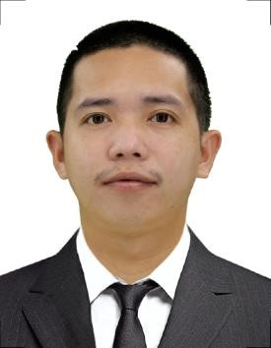

Erwin A.Pelias
Prk Riverside Ibabang Dupay Lucena City
09096611762
erwinpelias1994@gmail.com

Career Objective: To contribute my skills.To enhance my knowledge and to have more experience in your company.
Personal Background:
Age: 27
Birthdate: December 28,1994
Birthplace: Patnanungan Quezon
Religion: Roman Catholic
Language: Tagalog/English
Educational Attainment:
Tertiary: Lucena Manpower Skills Training Center
City Hall Annex Bldg.Brgy.Isabang Lucena City
Shielded Metal Arc Welding NCII
September-December 2013
Secondary: Lucena City National High School
Ibabang Dupay Lucena City
2008-2012
Primary: Lucena North II Elementary School
Ibabang Dupay Lucena City
2002-2008
Seminars and Trainings:
Technical Skills System of Lucena Inc.
Metal Insert Gas (MIG Welding)
Lucena City
Dec.14,2013

Achievement /Accomplishments:
Computer Systems Technological Center
Shielded Metal Arc Welding (SMAW NC II)

Work Experience:
Yutuka Manufacturing Phil.Inc Isuzu Philippines Corporation
Laguna Technopark Biñan Laguna Phase II Laguna Technopark Biñan
Welder/Machine Operator Operator/Assembler
January 3,2014-January 25,2017 March 21,2017-August 18,2017

Pro-care Security Services
Mt.Carmel Diocesan General Hospital
Security personnel
March 2018- Present

Character References:
Fernando Lotino Jomar Buenaobra
Head Security Laboratory Assistant
09222717549 09073811698

I hereby certify that the above information is true and correct according to my knowledge and beliefs.
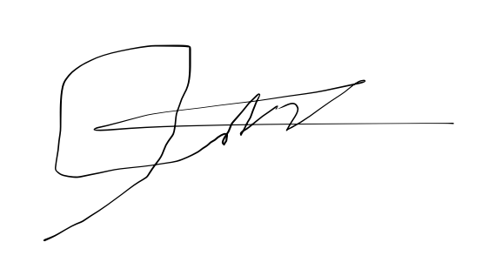

Erwin A. Pelias
Applicant

