Pasig City
09108892470
iamurcesio@gmail.com

September 28, 2022

MERCAN CANADA EMPLOYMENT
Philippines Incorporated
Unit 502 Galleria Corporate Center
Edsa Corner
Ortigas, Quezon City

Dear Maam/Sir:

I have learned that your searching for an Forklift Operator. I am Urcesio B. Sistoso Jr a highschool graduate, a professional Licensed Driver (1,2,3) and also have a NC II driving operator.

In great appreciation, I am writing to apply as an Forklift Operator. I believe that my education, skill-set, trainings and experience make me suitable candidate for this role. I am excited about the possibility of working for you as a Forklift Driver where I will have an opportunity to grow both personally and professionally.

I have enclosed my resume together with this application letter. I hope you will give me the opportunity to discuss further my personal qualifications. You can reach me through the contact numbers or the email address written above, at any time you find most convenient.

God bless and thank you very much.

Respectfully yours,

URCESIO B. SISTOSO JR.
Applicant

Enclosure: Resume

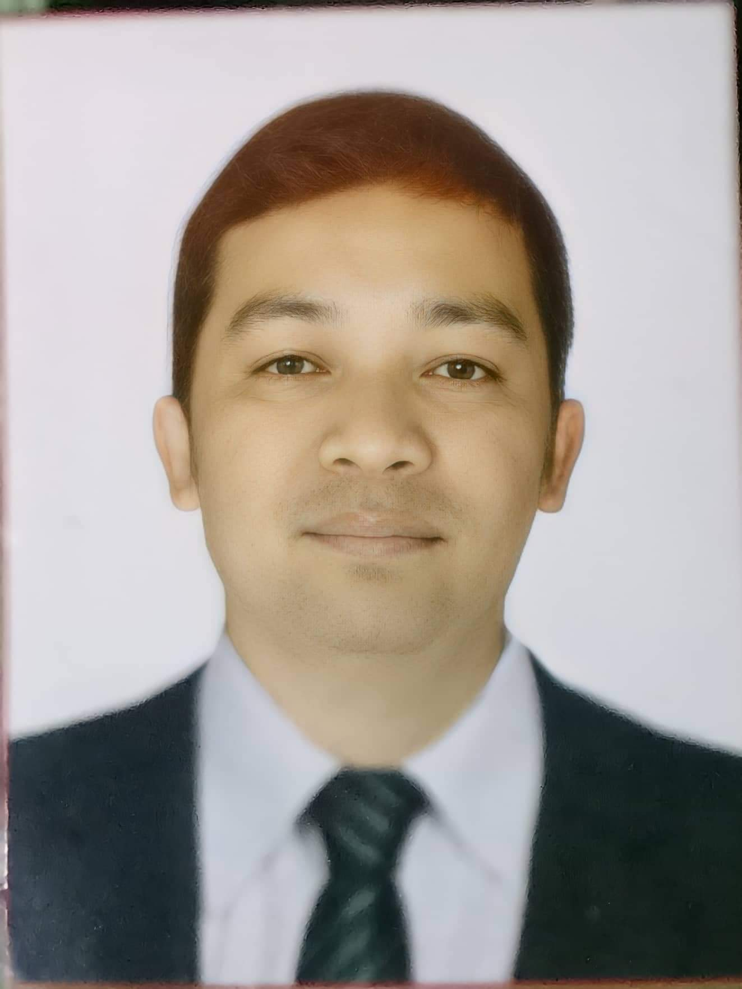
URCESIO B. SISTOSO JR.
Quezon City
Mobile Phone Number: 09108892470
E-mail address: tikzmithjr@gmail.com

PERSONAL PARTICULARS
Age : 33
Date of Birth : March 1, 1989
Height : 5"3
Weight : 60kg
Father’s Name : Urcesio Tipan Sistoso Sr.
Mother’s Name : Lucena Pat Bayarcal
Marital Status : Single
Religion : Roman Catholic
Citizenship : Filipino

OBJECTIVE
To expand my knowledge and skills during our actual work experience in the workplace.

EDUCATIONAL BACKGROUND
Bukidnon National School of Home Industries Maramag, Bukidnon. (2005-2006)

WORK EXPERIENCE
Nestle ( Ace Conglomerate Distributor Inc.) 2015- 2016 Driver/Truck..
APEX Mining Corporation Incorporated. 2017-2022 Driver/Operator.

CHARACTER REFERENCE
Jorolan, Jhonard G.
ACFT Refueller Driver
Pasay, City
09912244603

