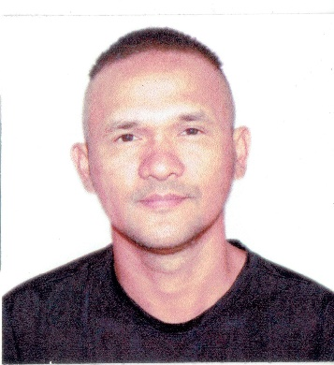
NAME : CLIDE BAHAY LLANITA
BIRTH DATE : MARCH 19, 1984
AGE : 38
GENDER : MALE
CITIZENSHIP : PHILIPPINES
RELIGION : CHRISTIAN
BIRTH PLACE : TUKURAN ZAMBOANGA DEL SUR
STATUS : SINGLE
LANGUAGES : Malaysian, Tagalog, Bisaya, English
clidellanita@gmail.com
Cagayan De Oro City PH.
09611613492

OBJECTIVE OVERVIEW

(WCFW) World Class Filipino Workforce Certified, Developed extensive skills and experience in a wide variety of Maintenance Technician position. Self-starter, dedicated to achieving high-quality results.

EDUCATION AND CERTIFICATION

CERTIFICATE
School/University : EXECUTIVE TECHNICAL CONSULTANTS
TRADE TEST AND TRAINING CENTER INC.
Education Field : Trade Test Specialist
Training and Skills Upgrading
Technical Services
Course : Maintenance Technician
Location : Sta. Ana, Manila, Philippines
Year : April 2015

DIPLOMA
School/University : KEMENTERIAN PENGAJIAN TINGGI MALAYSIA
POLITEKNIK KOTA KINABALU
Educational Level : Vocational Diploma/Short Course Certificate
Education Field : Engineering,Electrical,Electronics
Course : KEJUTERAAN ELEKTRIK (Electrical Eng.)
Location : Kota Kinabalu, Sabah, Malaysia
Year : Year 2003
Training Seminars
School/University : KAMPUS ANTARABANGSA LABUAN
Education Field : Engineering,Electrical,Electronics
Course : Electrical Engineering
Location : Labuan , Malaysia
Year : Year 2000

RELATED WORK AND SKILLS EXPERIENCE

Company : Al- Watania Poultry Institute of Technology
Location : Al-Bukayriah, Al Qassim, Kingdom of Saudi Arabia
Duration : May 14, 2015 to May 14, 2020
Position : General Maintenance Technician
Job Description : Electrician technician, Plumbing, General Maintenance, Winding, Air
Condition Technician,

Company : P.L.D.T. PHILCOM TELECOMMUNCATION
(Serveflex Inc.)
Location : Cagayan De Oro City, Philippines
Duration : June 2014 – March 2015
Position : Telecommunication
Job Description : Networking, Troubleshooting Internet connection and Telephone, Fiber Optic

Company : NURAIN ELECTRIK SDN BHD. (M)
Location : Kota Kinabalu, Sabah Malaysia
Duration : Jan 2010 – Feb 2013
Position : Electrician Supervisor
Job Description : Rewinding AC/DC Electric Motors, Electrical Industrial

Company : FUNG GUAN ENTERPRISE
Location : Lahad Datu, Sabah, Malaysia
Duration : Year 2008 - 2010
Position : Electrician Maintenance and Rewinding Electrical Motors
Job Description : Rewinding AC/DC Electric Motors, Electrical Industrial

Company : SUMMER SUCCESS SNOOKER
Location : Tawau, Sabah, Malaysia
Duration : Year 2005 - 2008
Position : Maintenance Technician
Job Description : Electrical, HVAC, General Maintenance

Company : STANDARD ELECTRIC SDN BHD.
Location : Tawau, Sabah, Malaysia
Duration : Year 2003 – 2005
Position : Electrician

OTHER SKILLS
Driver (with Philippines, Malaysia, Saudi Arabia License)
Computer Technician
Telecommunication Technician
Winding
Plumbing
Air Conditioning Technician

