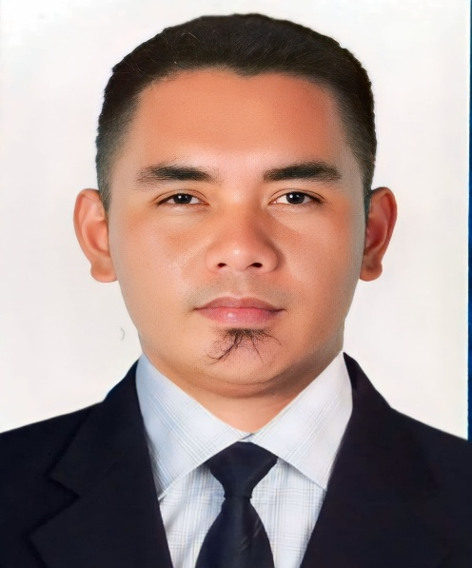

**DOMINIC JHON S. ROSARIO**

Contact Number: **09350736696**

Email address: [**03dj.rosario@gmail.com**](mailto:03dj.rosario@gmail.com)

Address: **266 Aglipay Street, Dugo Camalaniugan,Cagayan Valley Philippines**

**OBJECTIVE:**

To able to work for a progressive, stable professionally managed organization where I will have the opportunity to expose my skills and capabilities will be fully utilized and therefore strengthened career advance.

**PERSONAL INFORMATION:**

Age: 26

Date of Birth: July 24,1996

Place of Birth: Camalaniugan,Cagayan

Civil Status: Married

Citizenship: Filipino

Height: 172 cm

Weight: 78 kls

Gender: Male

Religion: Iglesia Ni Cristo

**EDUCATIONAL BACKROUND:**

Primary: Dugo Elementary School

Dugo Camalaniugan,Cagayan

2003-2009

Secondary: Camalaniugan National High

School

Dugo Camalaniugan,Cagayan

2009-2013

Tertiary: TESDA-APARRI POLYTECHNIC

INSTITUTE

Maura Aparri,Cagayan

SHIELDED METHAL ARC WELDING-NC2

**WORK EXPERIENCE:**

**\***RACAL MOTORSALES CORPORATION

Macanaya Aparri, Cagayan

Mechanic

January 2014-December 2014

*BEST ALLIED SERVICES INTEGRATED COMPANY INC.

General Eduardo Batalla Camalaniugan,Cagayan

Service Crew

January 2015-September 2022

PERSONAL SKILLS

*Mechanic

*Welder

**CHARACTER REFERENCES:**

*Christel C. Mabutas

CASHIER

09261029366

BASIC INC.

*Kristine S. Usinia

OIC

09657956868

BASIC INC.

I hereby certify that the above information is true and consistent to the best of my knowledge and beliefs.

DOMINIC JHON S. ROSARIO

Applicant