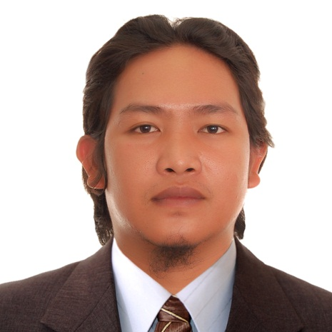
FRANCISCO P. DUYUGEN JR.
Blk 75 Lot 22 Madiwara St.
Fiesta Communities Catillejos
Brgy. Del Pilar, Castillejos, Zambales
+639054837161

POSITION DESIRED: FCAW/MIG WELDER

JOB OBJECTIVES:

Obtain a job where I can apply my knowledge, skills, expertise and experience in welding. This position should test my skills daily to help me gain more knowledge and experience while being asset to the company.

SUMMARY OF QUALIFICATIONS:

- Welding experience of more than 4 years in a big Japan-based company mainly engaged in the design, manufacture and construction of steel frames and other steel structures.
- Welding experience in shipyard for 3 years.
- Q3 Certificate of Welder and Welding Operator Qualification
- Skilled and competent in welding process of Flux Cored Arc Welding (FCAW)
- Trained and experienced in Metal Inert Gas (MIG)
- Proficient in operating remote pendant crane 5ton
- Flexible and hard working
- Can handle under pressure with minimal supervision
- Fast learner and can get along with superiors and co-workers smoothly

WORK EXPERIENCE:

FCAW and MIG Welder – Welding Department
Kawagishi Bridge Work Co., Ltd.
Kawagishi Kogyo
1055 Takata, Kashiwa, Chiba 277-0861 Japan
May 2018 to present

Duties and Responsibilities:
- Responsible for being proficient in the FCAW process to weld various components in flat, vertical, or overhead positions. Welds according to the company's engineering specification on process piping, equipment, and structural steel.
- Measure, cut, and assemble metal projects using an electric arc and inert gas (MIG). Select suitable material, ensure the work area is safe, prepare metal surfaces, determine gas ratios, and inspect weld strength during and after the welding process.
- Set up, adjust, and operate the remote overhead crane 5ton to move material throughout the designated area for it to be worked on. Set up, adjust, and operate crane equipment safely.
- Perform welding repair using gauging machine.
- Use Shielded metal arc welding (SMAW) as needed.
- Assist other job work as deemed necessary.

FCAW (Q3) Welder – Special Assembly Department
Hanjin Heavy Industries and Construction Co. LTD
HHIC-Phil. Inc – SHIP BUILDING
Greenbeach 1, Redondo Peninsula, Subic Bay Freeport Zone 2222
July 2014 to September 2017

Duties and Responsibilities:
- Responsible in full welding carbon steels that is used in building ships such as brackets, erection joints, simlines and double bottom and other parts of the ship using flux cord arc welding (FCAW).
- Perform welding repair using gauging machine.
- Repair all other work after identification that weld done by welders fails to passed ultrasonic test (UT).
- Assist other job work as deemed necessary.

EDUCATIONAL BACKGROUND:

Secondary: Jose C. Payumo Memorial High School
Naparing, Dinalupihan, Bataan

Elementary: Pinulot Elementary School
Pinulot, Dinalupihan, Bataan

PERSONAL DATA:

Date of Birth: January 11, 1990
Religion: Catholic
Place of Birth: Dinalupihan, Bataan
Citizenship: Filipino
Height: 175 cm
Weight: 82 kg

I certify that the above information are true and correct to the best of my knowledge and beliefs.

FRANCISCO P. DUYUGEN JR.
Applicant

