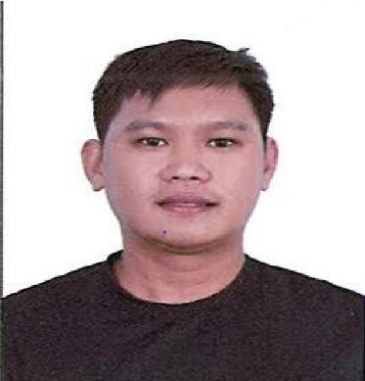
Ramon Tamoria Legaspi
Home address: 0574 Prk.4 Brgy. Calapandayan Subic, Zambales Contact: +639122088367
Email: legaspirham@gmail.com Passport #: P0119943B

Objectives:
- To obtain a job that best fits my qualifications and increase my knowledge in line with my expertise.
- To build high quality of loyalty for the company to keep myself tract with the position and cooperation between my superiors and co-workers.
- To use my talents and skills in different field of operation i assure to give my full service in my capacity, knowledge and connections only the best at high standard level of service at all time.
- To spare my extra time, effort and skills for the company.
To accept the fundamental duties assigned to me and assure the management with direction and guidance that the designation will be fully implemented with high spirit and dedication.

Personal information:
Name: Ramon Tamoria Legaspi Religion: Roman Catholic
Sex: male Nationality: Filipino
Age: 30 years old Civil status: Married
Date of birth: June 27,1992 Spouse: Ronela Aquino Legaspi Place of birth Subic, Zambales Philippines Language Spoken: English & Tagalog Height: 5’4

Educational Background:
- Tertiary – Computer Technician
Central Luzon College of Science and Technology (June 2009- October 2009) Olongapo City, Zambales
- Secondary- Subic National High School
Subic Zambales (2005-2009)
- Primary- Calapandayan Elementary School Subic Zambales

Experiences
Company: Keppel Subic Shipyard Inc. (Ship building & ship repair industry) Address: Subic Zambales Philippines 2209
Position: ship Fitter fabricator and Plater (November 2011- October-2018) Job description:
Joining of plates, tack welding, cutting, panelling, semi-automatic cutting (Radial), Fabricating of Angle bars T-sections Bulb plate etc. Edge base on shop drawing, preparation and plate joining, grinding, crop-out and wash-out of deteriorated or damage plates and renew. joining of block to block erection.
Machines to operate: Bending machine 1000 tons
Rolling Machine up to 1500tons

Company: Zamil Offshore (ship building and ship repair industry) Address: Dammam Seaport, Dammam Saudi Arabia
Position: Ship fitter, Aluminium Fabricator and Machine Operator (March 2, 2019-present) Job description:
Edge preparation and plate joining, fabricating of materials base on drawing. Cutting of bulbs, angle bars I-beams etc. grindings, preparation of materials, top deck, bulk heads, top tanks, bottom plates and side shells erection and repair crop-out and fit-up etc.

Machines to Operate:
Press brake Machine (baykal APHS 4100x500)
(Delem DA-53T – PR6 400x6500)
Rolling Machine (HAEUSLER) Swaging Machine ()
Job description: Before start check the machine if there is any obstraction or leakage, preparation and marking of materials base on shop drawing, alignment and proper position of materials before bending or rolling base on radius/template needed

Character Reference:
- Reymond Sanchez (reymon.sanchez@zamiloffshore.com) QA/QC Document Controller/ Secretary
- Armando Coronel Jr. (armandocoronel198304@gmail.com)
Machine Operator

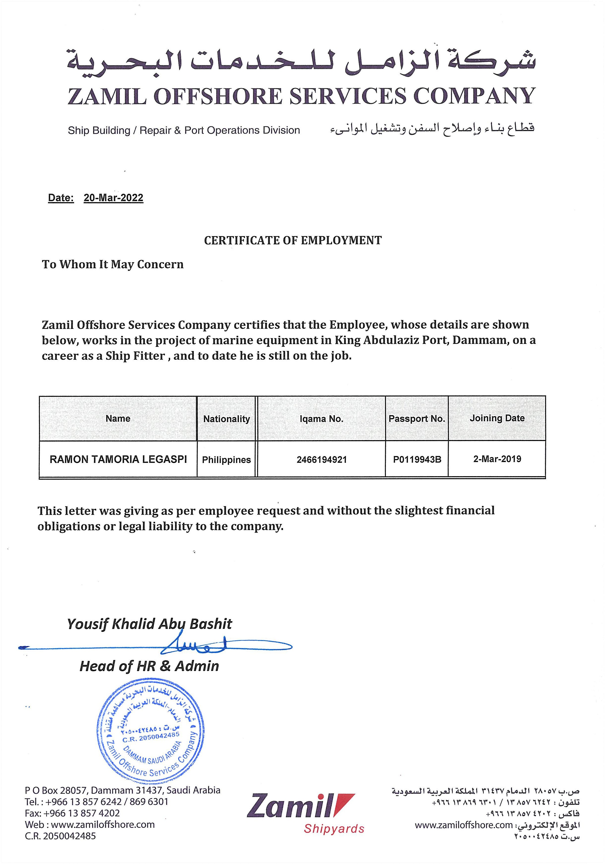

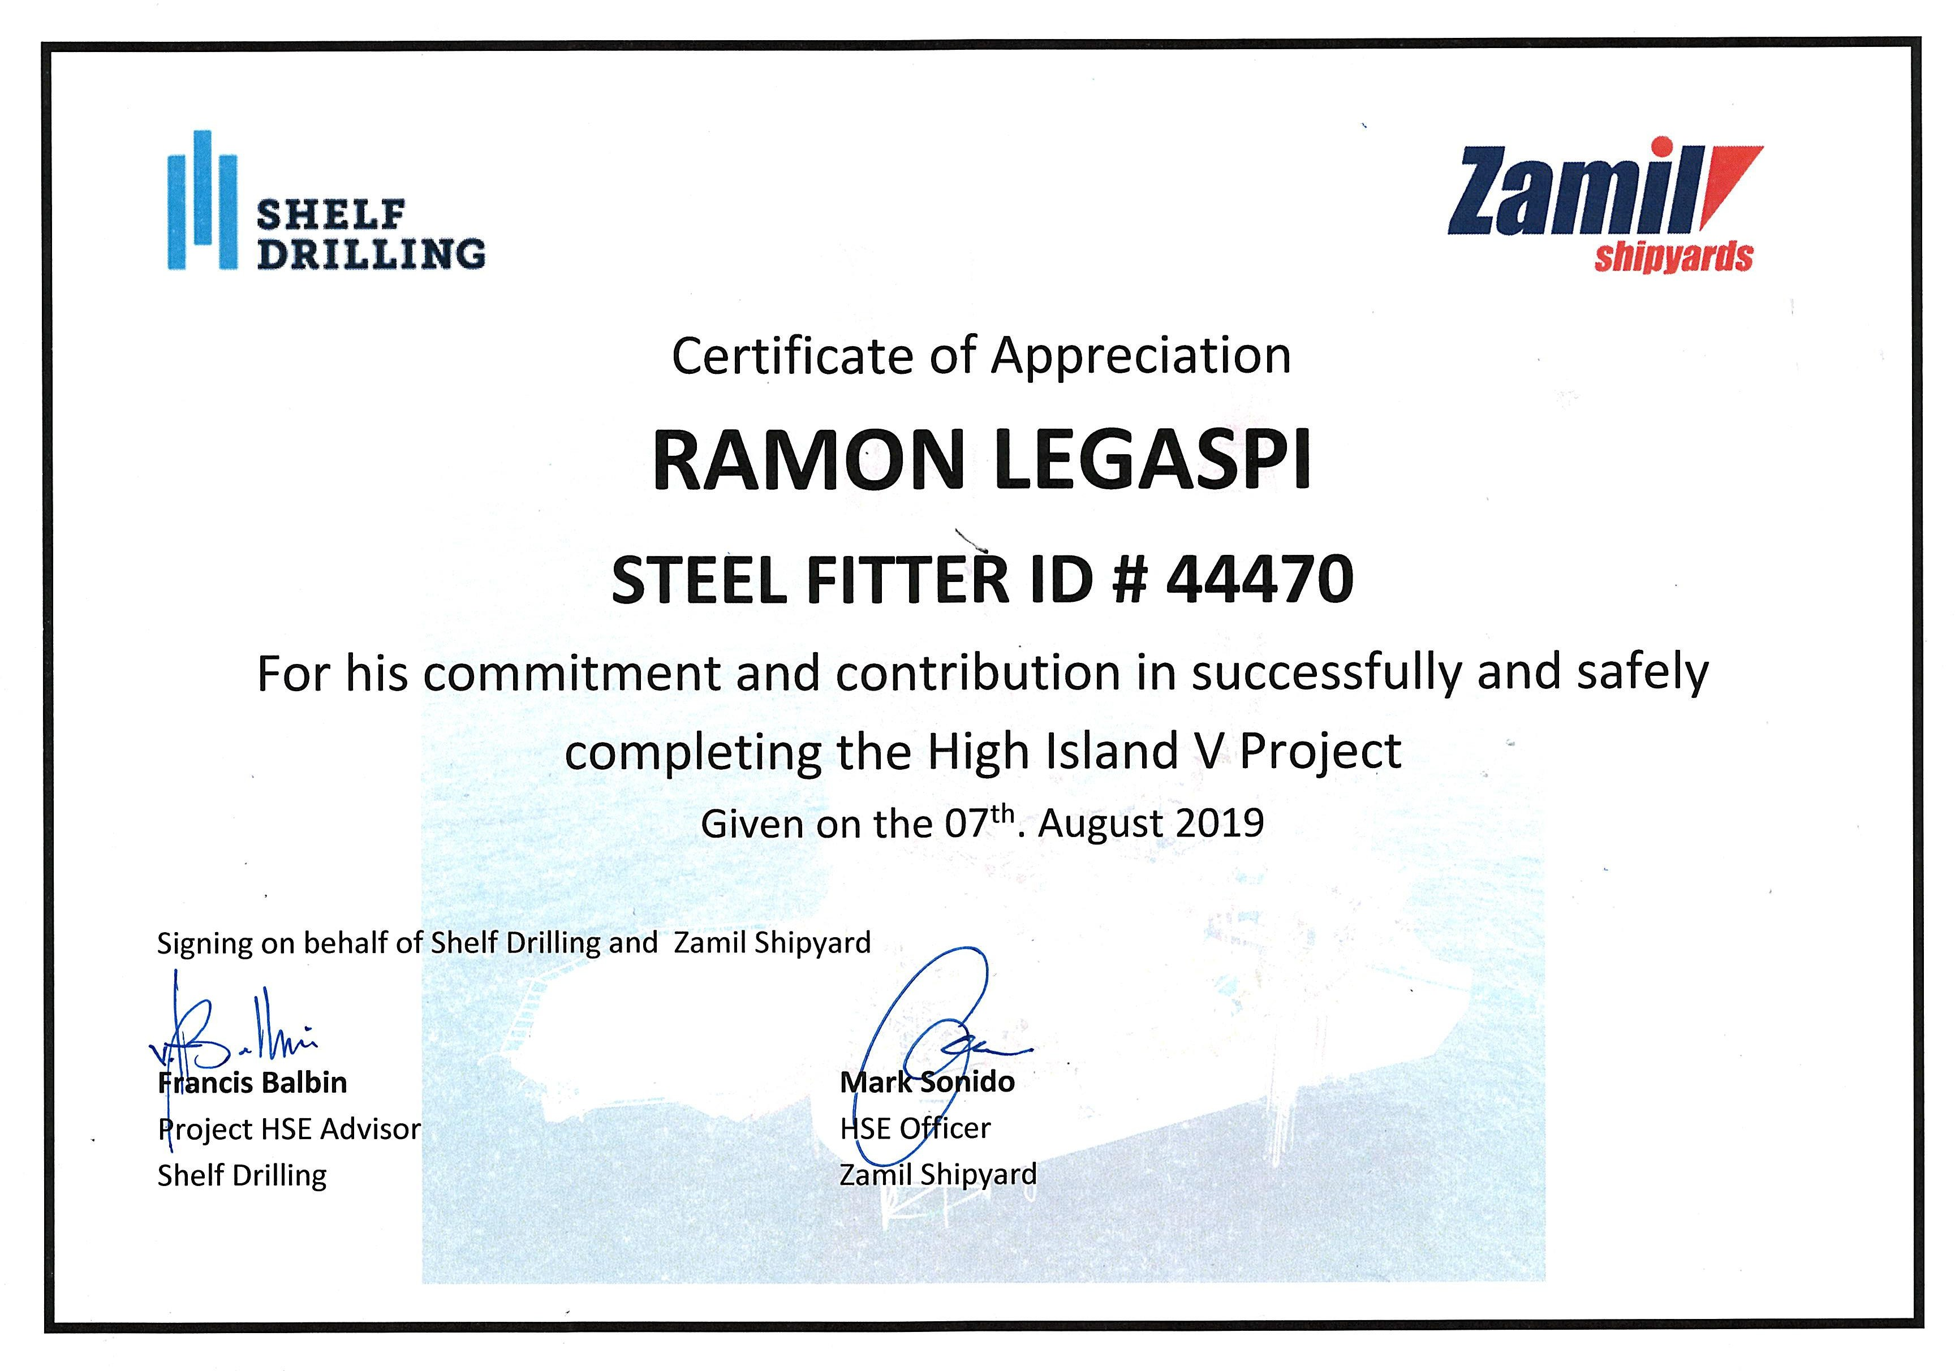

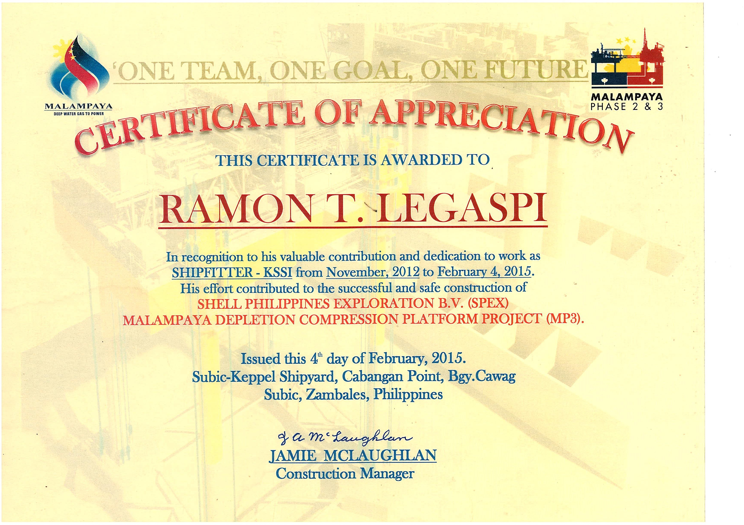

NO 00732101
REPUBLIC OF THE PHILIPPINES DEPARTMENT OF LABOR AND EMPLOYMENT
PHILIPPINE OVERSEAS EMPLOYMENT ADMINISTRATION

PRE-EMPLOYMENT ORIENTATION SEMINAR

NAME LEGASPI, RAMON TAMORIA
COMPLETION DATE 2018-January-10 5:47 PM

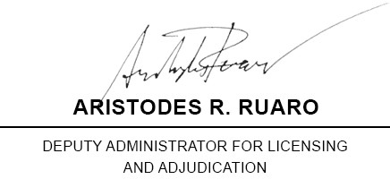
legaspirham@gmail.com
549ef119622c751b80ec80620c6aa1d2a7d1fced

DECLARATION
I declare that:

I have read and understood the eight (8) learning modules of the PEOS Online; and I have completed all the modules without the help of anybody else.

I attest to the truth of the foregoing declaration.
(sgd). RAMON TAMORIA LEGASPI

10 REMINDERS TO AVOID ILLEGAL RECRUITMENT

- APPLY ONLY WITH LICENSED RECRUITMENT AGENCIES. DON'T APPLY WITH CONSULTANCY FIRMS, TRAINING CENTERS, TRAVEL AGENCIES, AND FOUNDATIONS THAT PROMISE JOBS ABROAD.

- CHECK WITH POEA WHETHER THE POSITION YOU ARE APPLYING FOR HAS AN APPROVED JOB ORDER

- TRANSACT ONLY WITH AUTHORIZED REPRESENTATIVE OF A LICENSED AGENCY.

- TRANSACT BUSINESS ONLY AT THE REGISTERED ADDRESS OF THE AGENCY.

- PAY ONLY THE ALLOWABLE PLACEMENT FEE. IT SHOULD BE EQUIVALENT TO ONE MONTH SALARY, EXCEPT IN CASES WHERE CHARGING OF PLACEMENT FEES IS PROHIBITED.

- PAY THE PLACEMENT FEE ONLY AFTER YOU HAVE SIGNED AN EMPLOYMENT CONTRACT. DEMAND AN OFFICIAL RECEIPT REFLECTING THE ACTUAL AMOUNT PAID AND PURPOSE FOR WHICH PAYMENT WAS MADE.

- BE WARY OF JOB OFFERS THROUGH THE INTERNET THAT REQUIRE APPLICANTS TO REMIT IMMEDIATELY PAYMENT FOR INTENDED VISA, AIRFARE, AND PROCESSING COSTS.

- BE WARY OF ADS OR BROCHURES REQUIRING YOU TO REPLY AND TO ENCLOSE PAYMENT FOR APPLICATION FORMS AND PROCESSING OF PAPERS.

- MAKE SURE THAT YOU HAVE THE APPROPRIATE WORK VISA/PERMIT. BE WARY OF JOB OFFERS USING TOURIST OR VISIT VISAS.

- TRANSACT DIRECTLY WITH GOVERNMENT OFFICES/ PERSONNEL. NEVER DEAL WITH FIXERS.

Form generated by PEOS Online (http://peos.poea.gov.ph) on Jan 10 2018 17:58:27

