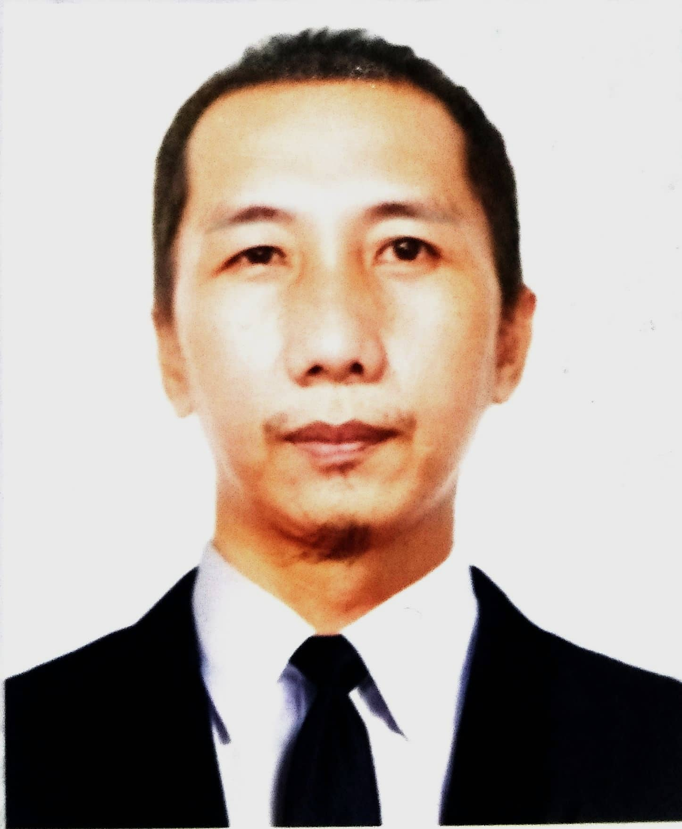 |  | Rentoria, resty d.
objectives  - To contribute in the growth and development of the company while interacting with people varied concern.  - To gain knowledge and grow personally and professionally to expand my full potential on the course training.  Contact  Cellphone #:  09762311065/ 09554100113  Email:  Rentoriaresty30@gmail.com  Address:  Mahabang Dahilig, Batangas City  Summary of qualification  - Goal oriented  - Knowledge in FCAW  - Knowledge in GTAW, SMAW 2G/3G/4G  - Can communicate in oral and written (English & Tagalog)  - Follow standard working safety procedures  - Willing to undergo training and seminars  - Can handle pressure and deadline competently. |  | EDUCATION  Technical Educational and Skills development Authority (TESDA)  Batangas City  July 07, 2006  Batangas State University  Batangas City  2000-2001  Bauan High School  Bauan, Batangas City  1999-2000  San Pedro Elementary School  Sta. Maria, Bauan, Batangas  1998-1999  WORK EXPERIENCE  AG&P Atlantic Gulf and Pacific Company of Manila Inc.  Shop Fabrication Group  San Roque, Bauan, Batangas  Project: Ilijan LNG Import Facility Project 15 June 2022 – Present  Clean Fuel Project 05 Nov 2020 – 20 Aug 2021  YAMAL 15 June 2015 – 25 January 2016  JKC/ Ichthys LNG 29 May 2014 -14 June 2015  Lycho/ Lycopodium 15 January 2014 – 28 May 2014  Flour Doow 08 August 2013 – 28 November 2013  EEI Corporation Construction Division  Shop Fabrication Group  Brgy. Sta. Maria, Bauan, Batangas  Project: MRT Skyway 21 Sept 2016 – 10 Sept 2020  (Steel Fabrication Division)  EEI Corporation Construction Division  Brgy. Simlong, Batangas  Project: JG Summit 11 February 2012 – 29 June 2013  EEI Corporation Construction Division  Shop Fabrication Group  Brgy. Sta. Maria, Bauan, Batangas  Project: GORO 06 Nov 2006 – 17 Aug 2010

JOB DESCRIPTION

- Withdraw filler wire, electrode and flux from the rod controller with ECS request.
- Follow specific instructions from the welding foreman.
- Attend daily tool box meeting or any meeting requiring presence.
- Ensure cleanliness and quality of completed welds.
- Always follow safety requirement

