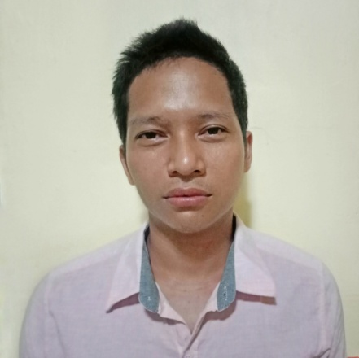
FORTUNATO A. VALENCIA JR.
DATE OF BIRTH: August 08, 1992
AGE: 30 years old
STATUS: Married
NATIONALITY: Filipino
ADDRESS: San Nicolas, Canaman, Camarines Sur
PHONE: 09068515724
EMAIL: fortunatovalencia@gmail.com

CAREER OBJECTIVE

- To bring efficient skills, experience and knowledge related to the certified welding filed and continue to make advances to the career.

EMPLOYMENT HISTORY

2010-2013 KEPPEL SUBIC SHIPYARDS
Pipe Welder
Cabanggan Pt. Cawag Subic, Zambales Philippines

2013-2017 DRY DOCKS WORLDS
Pipe Welder
Dubai U.A.E

2019-2020 ARDNOSIL CONSTRUCTION & GENERAL SERVICeS
Sub-contractor of Jet Tech Energy Corporation
MW Boac Diesel Power Plant Project
Pipe Welder (GTAW/SMAW)
Boac DPP, Brgy. Bantad, Boac, Marinduque

2021-2022 ARDNOSIL CONSTRUCTION & GENERAL SERVICES
Sub-contractor of Jet Tech Energy Corporation
Diesel Power Plant Project
Pipe Welder (GTAW/SMAW)
Brgy. Carayman, Calbayog City, Western Samar

SKILLS

- Pipe Welder (GTAW-SMAW-FCAW-GMAW) in all position.
- CS-SS- Cupro Nickel- Supper Duplex Metal

EDUCATION

SY: 2005-2009 Secondary
Mangayan High School
Canaman, Camarines Sur

SY: 1998-2005 Elementary
San Nicolas Elementary School
Canaman, Camarines Sur

TRAININGS ATTENDED

Jan-May 2011 SMAW (Shielded Metal Arc welding) NC I/ NCII
TESDA-Kolping Society Philippines
Canaman, Camarines Sur

June-Aug. 2011 GTAW/SMAW (Combination of SMAW and Tig)
Keppel Subic Shipyard Incorporated

CERTIFICATION

Jan. 05, 2016 to OFFSHORE
Jan. 06, 2017 Topside fabrication, Installlation and Integration project
FPSO CYRUS

CHARACTER REFERENCES

- Available upon request.

I hereby certify that the above information are true and correct to the best of my knowledge and belief.

FORTUNATO VALENCIA JR.
APPLICANT

