MATANGUIHAN, ARWIN LAUREL 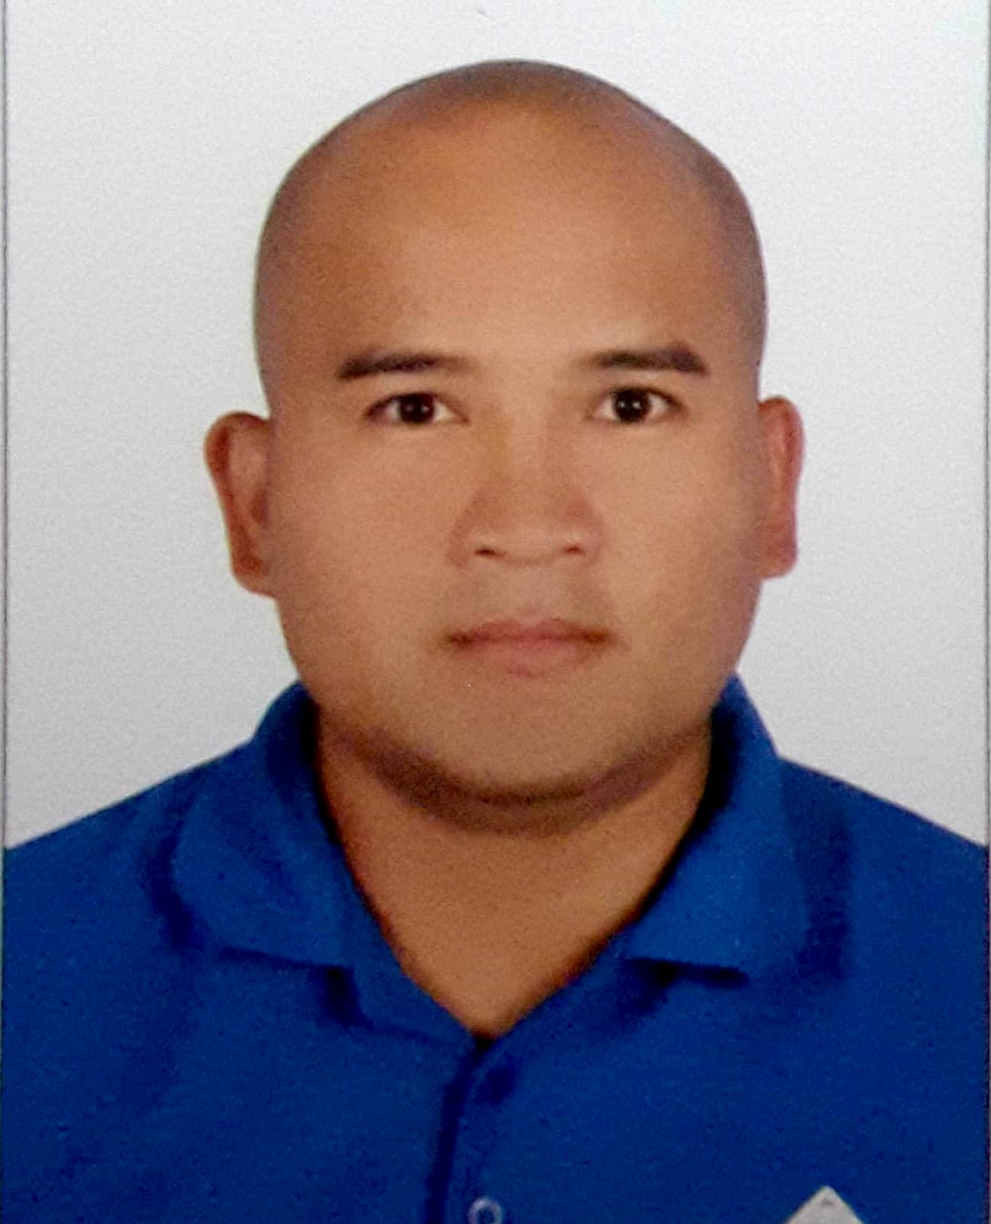

Permanent address:
Tramo Street Barangay Maulawin
Pagsanjan, Laguna Philippines

Mobile number : +63 919 651 5752

Email: awenmat@yahoo.com

JOB OBJECTIVE:

To attain a position that will allow growth, develop leadership potentials as well as to ensure
professional stability.

EDUCATION

DON BOSCO MANPOWER TRAINING CENTER

Industrial Mechanics (1996 - 1997)

WORK-RELATED EXPERIENCE

MACHINIST / MECHANICAL TECHNICIAN ( Coventional Machinist,CNC Operator, Shot-peen Operator, QC)
ANSALDO THOMASSEN GULF GCC – April 2015 to April 20 2018

Assigned on many types of mechanical repair and replacement tasks for Frame 5 to Frame 9 Gas Turbine Hot
Components (e.g. turbine rotor buckets/blades, nozzle, vane, liner and transition piece) able to set-up and operate
CNC milling machine, partial programming and adjustment, able to operate conventional lathe, milling and grinding
machine, Set-up and Operate shot-peening machine, Production / Assembly fixture inspection and evaluation with
close coordination with engineering department.

MECHANICAL SKILLED TECHNICIAN (General Maintenance, Mechanical Department) QATAR ELECTRICITY
AND WATER COMPANY – April 2010 to April 2015

Assigned on many types of mechanical repair and replacement tasks, maintains the correct condition of parts on Gas Turbine and Desalination units. Monitor clearance and gaps for Turbine Blades and Bearing Casing during major overhauling, assist in repair and replacement of gas pipes and turbine burner, air filter replacement, fabrication of replacement components thru machining if needed.

QUALITY CONTROL LEADMAN (Quality Control, Fabrication Department) MICTROTECH ENGINEERING Technology Inc. - July 2001 to January 2010

Assures quality of all items of the fabrication department through dimensional and visual criteria’s; analyze drawings, new and revised for machining and measuring applications; provides and setup QC gauges and control tools for monitoring ; monitors and calibrate measuring tools and jigs; supports machining and assembly lines

MACHINE OPERATOR / MAINTENANCE (Production and Transmission Assembly Department) ASIAN TRANSMISSION CORPORATION – April 2000 to February 2001

Provides machine check-up reports to initiate machine maintenance; Machine set up for model transitions; Provides hourly check sheets before machine operations; Monitors machine output and tool life monitoring; machine operator; Responsible of tools and jigs material handling and safety; Transmission assembly and testing

LEAD INSPECTOR (Production Department) AMERICAN POWER CONVERSION – September 1998 to April 2000

Responsible for quality of materials for Japanese Models; Assembly of Uninterruptable Power Supply; Visual Inspector for Auto Insertion Line; Operates PCB Test Machines

TRAININGS AND SEMINARS ATTENDED

NEBOSH IGC January 24, 2014 to March 28, 2014
Doha Industrial Safety Services ( DISS ) QATAR

HAZARDOUS AREA ( Classification and Control ) November 07, 2014
Philippine Association of Safety Engineers Qatar

PROCESS SAFETY vs OPERATIONAL SAFETY September 05, 2014
Philippine Association of Safety Engineers Qatar

INDUSTRIAL HYGIENE for NON HYGIENIST August 22, 2014
Philippine Association of Safety Engineers Qatar

SAFETY TRAINING OBSERVATION January 03, 2014
PROGRAM ( S.T.O.P. )
Philippine Association of Safety Engineers Qatar

ENVIRONMENTAL MANAGEMENT: ISSUES February 07, 2014
AND SOLUTIONS
Philippine Association of Safety Engineers Qatar

COMMISSIONING SAFETY IN OIL AND November 08, 2013
GAS INDUSTRY
Philippine Association of Safety Engineers Qatar

BASIC PRINCIPLES AND PRACTICE OF May 31, 2013
RISK ASSESSMENT AND CONTROL
Philippine Association of Safety Engineers Qatar

OCCUPATIONAL SAFETY AND HEALTH IN March 15, 2013
CONTRUCTION INDUSTRY
Philippine Association of Safety Engineers Qatar

SETTING UP SAFETY IN THE WORKPLACE March 08, 2013
Philippine Association of Safety Engineers Qatar

OCCUPATIONAL SAFETY AND HEALTH IN February 15, 2013
CONTRUCTION INDUSTRY
Philippine Association of Safety Engineers Qatar

SMALL TOOLS CALIBRATION TRAINING COURSE November 8-9, 2006
Mitutoyo Asia Pacific Pte. Ltd.
Philippines Representative Office Muntinlupa City Philippines

DIMENSIONAL MTEROLOGY 1 – Basic Measurements September 13-15, 2006
Metal Industry Research and Development Center
Bicutan, Taguig City, Philippines

BASIC FIRE SAFETY SEMINAR August 21, 2001
Carmelray Industrial Park 2 Brgy. Tulo
Calamba City, Laguna Philippines

BASIC FORKLIFT OPERATION August 5-6, 1999
APC Carmelray Industrial Park 1
Calamba City, Philippines

7’S TRAINING May 13-14, 2009
APC Carmelray Industrial Park 1
Calamba City, Philippines

BASIC QUALITY CONTROL TRAINING November 29, 1999
APC Carmelray Industrial Park 1
Calamba City, Philippines

PERSONAL DATA

Born on July 24, 1980, in Canlubang Calamba Laguna. 37 years old, Married, Filipino citizenship, Roman Catholic. Average communication skills, Fair in speaking in English and fluent in Filipino. Dependable, Flexible, Analytical and Hardworking. Can work under pressure with minimal supervision. Willing to be trained in accordance to work requirements. Willing to work on graveyard shift.

