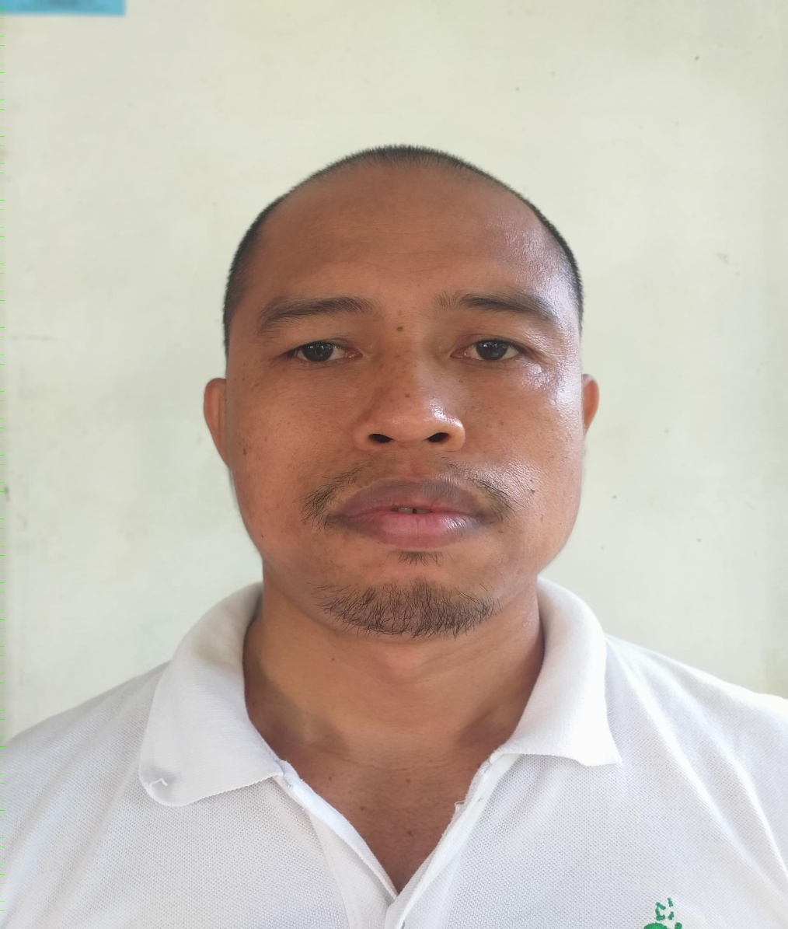

ELIAS PERO DELPONSO
Purok 4 Brgy. Alambre,Toril, Davao City
8025 Philippines
Contact no. +639558817463
Objective: To enhance my skills in my chosen field.
Personal Data:
Age: : 46 years old
Date of Birth : April 17, 1976
Place of Birth : Alambre,Toril, Davao City
Gender : Male
Civil Status : Married
Citizenship : Filipino

Educational Background:
Collage : University of Southeastern Philippines, Obrero, Davao City - 1999
Course : Diploma of Technology (DT)
Major : Automotive Technology
High School : Doña Carmen Denia City Highschool, Toril,Davao City - 1994
Elementary : Rizal Central Elementary School
Tagum City - 1989

Employment Background:
Auto Mechanic : Southern Maligaya Taxi Inc.
Matina Aplaya, Davao City - 1999-2012
Auto Mechanic : TEYSEER SERVICE CENTRE
Doha, Qatar - 2012-2021
Auto Mechanic : Tristar Logistics Inc.
Matina, Davao City - 2021-present
Respectfully Yours,
ELIAS PERO DELPONSO

