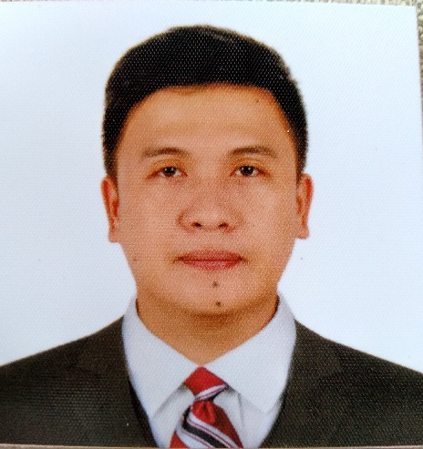

PERSONAL DATA:

First Name: Carl Dave
Last Name: Benliro
Nationality: Filipino
Date of Birth: April 09, 1988
Status: Married
Email Address: davebenliro88@yahoo.com.ph
Language: English, Tagalog
Mobile No.: +639952115900

OBJECTIVE

To practice nursing, which will make use of comprehensive health care training, excellent communication skills and self-directed prioritization. I am a dedicated individual, very responsible and capable of carrying out tasks with excellence. I always strive to do my best in everything that I do.

PROFESSIONAL EDUCATION
2006-2010 College Bachelor of Science in Nursing
College of Nursing, University of Mindanao
Davao City
2001-2005 Secondary Sta. Ana National High School,
Davao City

1995-2001 Primary S.I.R. Elementary School,
Davao City

WORKING EXPERIENCE
Southern Philippines Medical Center
JP Laurel Bajada, Davao City
ICU Nurse
October 12, 2022- Present

Almana General Hospital
Al Khobar, Kingdom of Saudi Arabia
Medical ICU Nurse
May 7, 2019- June 29, 2022

- Completes head to toe assessment to all patients and develops a written care plan upon admission.
- Initiates cardiac monitoring, oxygen therapy, invasive/non-invasive BP and oximetry, evaluate IV site, and evaluates existing drainage systems/catheters in place.
- Assesses the patient’s learning needs. Participates in patient/family teaching and works collaboratively with other health care team.
- Recognizes cardiac arrhythmias. Intervenes as per physician orders, ACLS protocols or ICU standing orders.
- Re-assesses patient status to identify progress of care and treatment or condition that requires further intervention, report as indicated.
- Ability to care for patients whose condition requires close observation, competent in care and monitoring of patient on mechanical ventilator and tracheostomy.
- Demonstrates skill in the operation/usage/ safe handling of equipment used in the unit.
- Competent in assisting clinician in any invasive procedures.
- Monitors patient with invasive monitoring (e.g. CVP)
- Ability to monitor hemodynamic status of patient.

Ricardo Limso Medical Center
V. Illustre St. Davao City
ICU Nurse
April 1, 2016- April 15, 2019

- Assess patients to determine the intensity of disease or trauma and create nursing care plans to meet his or her specific requirements
- Treat wounds by cleaning them by following preset directives and ensure that they are properly bandage and stilted.
- Records patients vitals including blood pressure, temperature and pulse in patients logbooks, on a periodic basis
- Administer oral medication and intravenous and intramuscular fluids, by first determining if patients have any allergies to medicine compounds.
- Observe patients to determine signs of discomfort or changes in conditions and ensure that any significant observations are communicated to the nurse manager or doctor.
- Respond to life-saving situations by performing first aid and CPR, in accordance to standard nursing protocols for treatment.
- Set up, regulate and maintain life saving or life maintenance equipment such as ventilators, and records patients response in an accurate manner
- Monitor catheters, leads and tubing to ensure proper placement and functioning.
- Calculate medication doses and titrate potent medications
- Insert and care for specialized venous and arterial infusions.
- Provide care to dying patients and provide education and support to family members faced with critical decisions.

Carlos P. Acosta Clinic and Hospital
L. Manuel St. Daliao Toril, Davao City
ER Staff Nurse
February 1, 2012- February 29, 2016

- Take care and treat ill, injured, and disabled patients.
- Assisted the physician in treatments and minor surgical operations.
- Records the patient's symptoms and keep the patient’s medical records up to date, operate medical equipment.
- Administer medications and treatment and do follow-up visits when necessary.
- Manages basic life support needs and stabilizes patients until the attending physician is available, based upon nursing standards and protocol.
- Prepares and administers (orally, subcutaneously, through an IV) and records prescribed medications.
- Provided a broad range of general nursing care services in areas of vital signs, ECG, catheters, feeding tubes and IV insertion.
- Cleans and bandages wounds.
- Provides basic, bedside care.
- Maintains proper supplies and appropriate medical equipment to care for patients

LICENSE/CERTIFICATES
- Nurse Specialist
By: Saudi Commission for Health Specialties

•. Registered Nurse (License No. 0672409)
By: Republic of the Philippines
Professional Regulation Commission (PRC)

•. Certified IV Therapy Nurse (Card No. 11-014857)
By: Association of Nursing Service Administrators of the Philippines, Inc.
(ANSAP)
- Member of the Philippine Nurses Association, Inc (PNA No. 094000)

KEY SKILLS & STRENGTH
- Computer Literate
- Hardworking and energetic; flexible; adapt easily to change of environment and work schedule.
- Cooking

SEMINAR/TRAINING ATTENDANTS

• “BASIC LIFE SUPPORT (BLS) COURSE” conducted by Institute for Nursing Enrichment Training Center held at JICA building SPMC, Bajada, Davao City on February 8, 2014.

• “ADVANCED CARDIOVASCULAR LIFE SUPPORT (ACLS) COURSE” conducted by Institute for Nursing Enrichment Training Center held at JICA building SPMC, Bajada, Davao City on February 10, 2014.

• “Conscious Sedation” held at Almana General Hospital Dammam KSA on July 18, 2019.

- “Basic Life Support Course” held on June 6, 2021 accredited by Saudi Heart Association.

- “Advance Cardiac Life Support Course held on December 31, 2020 accredited by Saudi Heart Association.

Character Reference
JULIET DEL CASTILLO, RN
Head Nurse
Ricardo Limso Medical Center
V. Illustre Street Davao City
Mobile No. 09272827554

ADIL MARTINEZ ARIP, RN
Unit QI/Staff Nurse
Almana General Hospital
Al Khobar, Kingdom of Saudi Arabia
Mobile No. +966542531542

AMR MOHAMED EMARA KHALIFA
ICU Intensivist Doctor
Almana General Hospital
Al Khobar, Kingdom of Saudi Arabia
Mobile No. +966543408161

