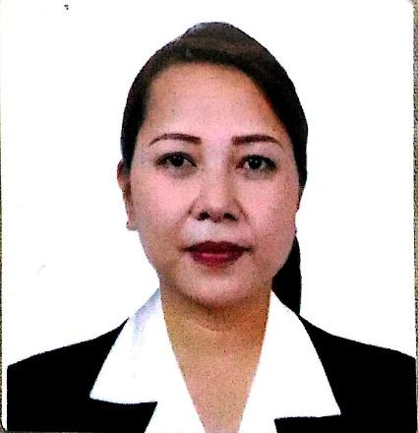
LORENA T. PASCUAL
318 Pria Road Pinagtipunan Gen. Trias
09950457442
pascuallorena9@gmail.com

OBJECTIVES

- To obtain a position within a company that would allow me to utilize my education and work experience for the benefit of the company, as well as for my personal growth and professional advancement.
- To seek a challenging career within a progressive organization that would utilize my skills, abilities, and education to the fullest extent.
- To contribute to the development of the company through the use of my skills and qualities.
- To create a positive working environment for our people through upheld values to take the chance to lead using high order overview skill, experience and wisdomin communication and information technology and insoireothers to lead thereafter.

EDUCATION
2011 TESDA Las Piñas City
Commercial Cooking NCII

1997 PERL COMPUTER CENTER, TAFT AVE.
Basic Computer

1990-1994 MUNICIPAL HIGH SCHOOL PARAÑAQUE CITY
High School Diploma

WORK EXPERIENCE
Nov'21 - Dec'21 TECH SUPPORT TRANSCOM PHILIPPINES
June”19 – June ’21 CLEANER, JUSSUR EMDAD INT’L RECRUITING COMPANY
July ’16 – Oct. ’16 HALL SUPERVISOR, LAUGHTRIP, COMEDY BAR
May ’16 – July ’16 FACILITIES/EVENT COORDINATOR, RYOAKI TAXI INC.
Jan. ’16 – May ’16 HR OFFICER, R.A.K. TRANSPORT INC.
Nov. ’15 – Dec.’15 TOURIST GUIDE, RYOAKI TRAVEL AND TOUR
May ’13 – Nov. ’13 JAPANESE TRANSLATOR, RTC BRANCH 90 IMUS, CAVITE
Jan ’12 – July ’13 STORE SUPERVISOR, D’ PEOPLES PARTS ‘N SALES, PASAY
July ’02 – Jan. ’03 BEAUTY CONSULTANT, SALLY HANSEN, SM BACOOR
Oct. ’02 – May ’03 FILING CLERK, GOLDRICH COMPANY, QUEZON CITY
Nov. ’01 – May ’02 CASHIER, BENCH, GLORIETTA MAKATI

ADDITIONAL SKILLS
Commercial Cooking NCII
Conversational Japanese
Fluent in Filipino
Conversational English
Basic Computer Knowledge
Microsoft Office Literate
Organizational Skills
Leadership Skills
Health and Beauty Knowledge

PERSONAL DATA

Date of Birth : May 11, 1976

Place of Birth : Mogpog Marinduque

Sex : Female

Civil Status : Single

Religion :Catholic

Father”s Name : Rolando Pascual

Mother”s Name : Lilian Pascual

CHARACTER REFERENCES

Available upon request

LORENA PASCUAL

